IVF / Fertility Clinic Management System
Doctor
Requirements Specification
Software Engineering – Laboratory Deliverable
Role: Drini Dalipaj / Christian Tasellari(Doctor)
March 2026

Table of Contents
1. Doctor Role Overview
2. Functional Requirements
3. Non-Functional Requirements
4. User Stories (6 Refined + 6 New) with Acceptance Criteria
5. User Scenarios List
6. User Scenarios Extended
7. Use Cases (7 Detailed)
8. Use Case Diagram Description
9. Activity Diagrams
10. Sequence Diagrams

1. Doctor Role Overview
The Doctor (Drini Dalipaj) is the primary clinical actor in the IVF / Fertility Clinic Management System. The Doctor is the central decision-maker in all treatment episodes, responsible for managing patient care from initial consultation through to IVF cycle completion.
Core Responsibilities:
- Patient Management: View and manage the list of assigned patients, including IVF cycle status and appointment schedules.
- Medical Records: Add and update clinical records including diagnoses, prescriptions, treatment notes, and supporting files.
- Appointment Management: Create, reschedule, and cancel patient appointments with automatic patient notification.
- Laboratory: Request lab tests with clinical instructions, set priority levels, and review results.
- Embryology: Monitor embryo development status, attach clinical notes, and issue transfer/cryopreservation/discard instructions.
- IVF Cycle Management: Review full IVF cycle history and authorize phase transitions.
- Critical Alerts: Receive and acknowledge real-time alerts for critical or abnormal test results.
- Emergency Access: Search and access any patient record in read-only mode during emergencies, subject to mandatory audit logging.

Access Level: The Doctor has read/write access to medical records, lab test orders, embryo clinical notes, IVF cycle phase transitions, and appointments for assigned patients only. The Doctor does not have access to billing, room management, or service catalog configuration (Administrator domain), or to upload laboratory results (Lab Technician domain).

2. Functional Requirements
The following table lists all functional requirements specific to the Doctor role. Each requirement is traceable to one or more user stories.

Req # | Requirement | Priority | Comments / Traceability
FR_D01 | The system shall display a list of all patients assigned to the logged-in doctor, showing name, Patient ID, active IVF cycle phase, and next appointment. | 1 | Supports US_01. List must refresh every 60 seconds.
FR_D02 | The system shall allow the doctor to filter the patient list by cycle phase, appointment date, or patient name. | 1 | Supports US_01.
FR_D03 | The system shall allow the doctor to add medical record entries (diagnoses, prescriptions, clinical notes, treatment plan updates) for assigned patients. | 1 | Supports US_02. Entries are immutable after saving.
FR_D04 | The system shall detect and warn the doctor of drug interactions when a prescription entry is submitted. | 1 | Supports US_02.
FR_D05 | The system shall allow the doctor to create, reschedule, and cancel appointments for assigned patients with automatic patient notification. | 1 | Supports US_03.
FR_D06 | The system shall provide a unified calendar view of all the doctor's appointments filterable by date range and patient. | 2 | Supports US_11.
FR_D07 | The system shall allow the doctor to request lab tests from a catalogue, attach clinical instructions, and set priority (Routine / Urgent / Stat). | 1 | Supports US_04.
FR_D08 | The system shall notify the doctor when lab results are available and flag abnormal results as URGENT. | 1 | Supports US_04, US_07.
FR_D09 | The system shall display embryo development data per IVF cycle including cell count, morphology grade, fragmentation, and status. | 1 | Supports US_05.
FR_D10 | The system shall allow the doctor to attach clinical notes to individual embryo records specifying transfer, cryopreservation, or discard instructions. | 2 | Supports US_09. Discard requires password re-authentication.
FR_D11 | The system shall display the full IVF cycle history for each patient including phases, medications, retrieval counts, embryo grades, and outcomes. | 1 | Supports US_08.
FR_D12 | The system shall require doctor authorization before advancing an IVF cycle to the next phase. | 1 | Supports US_10. Phase skipping is not permitted.
FR_D13 | The system shall deliver critical test result alerts to the doctor via in-system notification, email, and SMS within 60 seconds. | 1 | Supports US_07.
FR_D14 | The system shall escalate unacknowledged critical alerts to the on-call supervisor after a configurable window (default 30 minutes). | 1 | Supports US_07.
FR_D15 | The system shall provide a global patient search allowing read-only emergency access to any registered patient with mandatory reason logging. | 1 | Supports US_12.
FR_D16 | The system shall maintain a complete audit trail of all doctor actions including patient access, record entries, and phase authorizations. | 1 | Required for regulatory compliance.

3. Non-Functional Requirements

Category | Req # | Requirement | Priority
Usability | NFR_D01 | The doctor interface shall follow a consistent sidebar navigation with sections: Dashboard, My Patients, Appointments, Lab Tests, Embryology, IVF Cycles, Alerts. | 1
Usability | NFR_D02 | All doctor forms shall provide inline validation with descriptive error messages before submission. | 1
Performance | NFR_D03 | The patient list shall load within 2 seconds and refresh every 60 seconds. | 1
Performance | NFR_D04 | Critical alerts must be delivered within 60 seconds of the triggering event. | 1
Security | NFR_D05 | Doctor passwords shall be stored using bcrypt hashing. | 1
Security | NFR_D06 | Authentication shall use JWT tokens with a maximum session duration of 8 hours. | 1
Security | NFR_D07 | All doctor actions shall be logged in an immutable audit trail with user ID, action, timestamp, and affected record. | 1
Security | NFR_D08 | Emergency patient access is strictly read-only and generates an automatic audit log and notification to the assigned doctor. | 1
Availability | NFR_D09 | The system shall be available 99.5% of the time, excluding scheduled maintenance windows. | 1
Data Protection | NFR_D10 | All patient clinical data shall comply with Albanian Law No. 9887 on Protection of Personal Data and GDPR principles. | 1
Data Protection | NFR_D11 | Embryo records must be retained for a minimum of 10 years per clinic embryology policy. | 1
Data Protection | NFR_D12 | Medical record entries are immutable; corrections must be submitted as amendment entries. | 1
Portability | NFR_D13 | The doctor interface shall be a responsive web application compatible with Chrome, Firefox, Safari, and Edge. | 1
Scalability | NFR_D14 | The system shall support at least 20 concurrent doctor sessions without performance degradation. | 2

4. Doctor User Stories
This section contains 12 user stories for the Doctor role: 6 refined from the original requirements and 6 newly identified during analysis. Each story includes acceptance criteria.
Priorities: High = must-have for MVP; Medium = important for Sprint 3–4.

ID | User Story | Acceptance Criteria | Pri. | Status | Actor
US_01 | As a doctor, I want to view the list of patients assigned to me including their IVF cycle status and next appointment so I can plan my daily consultations efficiently. | Patient list shows name, Patient ID, DOB, active IVF cycle phase, and next appointment. Filters work by cycle phase, date, and name. List refreshes every 60 seconds. | High | Refined | Doctor
US_02 | As a doctor, I want to add and update medical records for my patients including diagnoses, prescriptions, and treatment notes so the clinical history remains accurate. | Doctor can add Clinical Note, Diagnosis, Prescription, or Treatment Plan Update. Drug interaction warning shown for prescriptions. Entry saved with UTC timestamp and doctor ID. | High | Refined | Doctor
US_03 | As a doctor, I want to create, reschedule, and cancel appointments for my patients so visits are coordinated and patients are notified automatically. | Appointments can be created, rescheduled, and cancelled. Conflict detection prevents overbooking. Patients receive automatic notifications for all changes. | High | Refined | Doctor
US_04 | As a doctor, I want to request lab tests with clinical instructions and priority level so the lab team processes samples correctly. | Doctor can select tests from catalogue, add instructions, and set Routine/Urgent/Stat priority. Lab Technician is notified. Stat orders trigger SMS within 60 seconds. | High | Refined | Doctor
US_05 | As a doctor, I want to view embryo development status including cell count, grade, and morphology for IVF patients so I can decide transfer or cryopreservation timing. | Embryo grid shows ID, day, cell count, grade, fragmentation, and status. Day-by-day lab log is accessible. Microscopy images displayed where uploaded. | High | Refined | Doctor
US_06 | As a doctor, I want to view anonymized donor profile information including compatibility and stock so I can match suitable donors with recipients. | Donor profiles are displayed anonymized per regulations. Compatibility parameters and available stock visible. Doctor cannot see donor identity. | Medium | Refined | Doctor
US_07 | As a doctor, I want to receive real-time alerts when a critical test result is uploaded for my patients so I can respond without delay. | Alert delivered via in-system, email, and SMS within 60 seconds. Alert includes patient name, test name, critical value, and direct link. Escalation triggered after 30 minutes if unacknowledged. | High | New | Doctor
US_08 | As a doctor, I want to view a patient's complete IVF treatment history across all previous cycles so I can tailor the current cycle protocol. | Full cycle history shows protocols, medications, retrieval counts, embryo grades, and transfer outcomes. Data is read-only and immutable. | High | New | Doctor
US_09 | As a doctor, I want to attach structured clinical notes to individual embryo records with transfer, cryopreservation, or discard instructions. | Instruction types: Transfer (Fresh), Transfer (FET), Cryopreserve, Discard, Await. Free-text rationale mandatory. Discard requires password re-authentication. Notes are immutable. | Medium | New | Doctor
US_10 | As a doctor, I want to explicitly authorize each IVF cycle phase transition so no phase begins without my sign-off. | Phase transitions require doctor confirmation. Phase skipping not permitted. Prerequisite override requires written justification logged to audit trail. | High | New | Doctor
US_11 | As a doctor, I want to view all my appointments in a unified calendar view filterable by date and patient so I can manage my schedule efficiently. | Calendar shows upcoming and past appointments. Filterable by date range and patient. No additional navigation required to view full schedule. | Medium | New | Doctor
US_12 | As a doctor, I want to search for any registered patient by name or ID and access their record in read-only mode in emergencies. | Global search searches all registered patients. Emergency Access modal requires clinical reason (min 10 characters). Access is read-only. Audit log created. Assigned doctor notified. | High | New | Doctor

5. User Scenarios List
The following table summarizes all user scenarios for the Doctor role. Each scenario is expanded in detail in Section 6.

ID | Scenario Name | Description
SC_D01 | Doctor logs in | Doctor logs in using credentials and is redirected to the clinical dashboard.
SC_D02 | View assigned patient list | Doctor views and filters the list of assigned patients with IVF cycle status.
SC_D03 | Open patient profile | Doctor selects a patient and opens their full medical record view.
SC_D04 | Add a medical record entry | Doctor adds a diagnosis, prescription, clinical note, or treatment plan update.
SC_D05 | Create an appointment | Doctor creates an appointment for an assigned patient.
SC_D06 | Reschedule an appointment | Doctor reschedules an existing appointment and patient is notified.
SC_D07 | Cancel an appointment | Doctor cancels an appointment with a mandatory reason.
SC_D08 | Request a lab test | Doctor requests a lab test with instructions and priority level.
SC_D09 | Review lab test results | Doctor reviews uploaded results and marks them as reviewed.
SC_D10 | View embryo development status | Doctor views embryo grid and day-by-day development log.
SC_D11 | Add clinical note to embryo | Doctor attaches transfer, cryopreservation, or discard instructions to an embryo.
SC_D12 | View IVF cycle history | Doctor reviews previous cycle records to inform the current protocol.
SC_D13 | Authorize IVF phase transition | Doctor confirms prerequisites and advances the IVF cycle to the next phase.
SC_D14 | Receive and acknowledge critical alert | Doctor receives a critical result alert and acknowledges it.
SC_D15 | Emergency patient search | Doctor searches for and accesses a non-assigned patient record in an emergency.

6. User Scenarios Extended
Each user scenario is expanded below with step-by-step flows, including both the normal path and exception handling.

SC_D01: Doctor logs in

- Doctor navigates to the login page.
- Doctor enters username and password.
- Doctor clicks 'Login'.
- System validates credentials.
- System identifies the user role as Doctor.
- System redirects to the clinical dashboard.
- If credentials are invalid: system displays an error and prompts retry.
- After 5 failed attempts: system locks the account.
SC_D02: View assigned patient list

- Doctor navigates to 'My Patients' from the dashboard.
- System retrieves all patients assigned to the logged-in doctor.
- System displays: full name, Patient ID, DOB, active IVF cycle phase, next appointment.
- Doctor applies optional filters: by cycle phase, appointment date, or patient name.
- System refreshes the list to match applied filters.
- Doctor selects a patient row to open their full profile.
- System loads the patient's complete medical record view.
SC_D03: Open patient profile

- Doctor selects a patient from the assigned list.
- System loads the patient profile: demographics, active IVF cycle, medical record summary.
- Doctor can navigate to sub-tabs: Medical Records, Appointments, Lab Results, Embryo Status, IVF History.
SC_D04: Add a medical record entry

- Doctor opens the patient profile.
- Doctor clicks 'Add Entry' and selects the entry type: Clinical Note, Diagnosis, Prescription, or Treatment Plan Update.
- System presents the appropriate form fields.
- Doctor completes all required fields and optionally uploads a supporting file.
- Doctor submits the entry.
- System validates required fields and checks for drug interactions if entry type is Prescription.
- If drug interaction detected: system shows warning modal; doctor must acknowledge before saving.
- System saves the entry with UTC timestamp and doctor user ID.
SC_D05: Create an appointment

- Doctor navigates to 'Appointments'.
- Doctor clicks 'New Appointment'.
- Doctor selects appointment type (consultation, procedure, follow-up).
- Doctor chooses date and time slot.
- System checks for scheduling conflicts.
- If conflict: system suggests alternative slots; doctor selects one.
- System creates the appointment and sends notification to the patient.
SC_D06: Reschedule an appointment

- Doctor selects an existing appointment.
- Doctor clicks 'Reschedule'.
- Doctor selects a new date and time slot.
- System checks for conflicts.
- System updates the appointment record.
- System sends automatic reschedule notification to the patient.
SC_D07: Cancel an appointment

- Doctor selects an appointment.
- Doctor clicks 'Cancel'.
- System prompts for a cancellation reason (mandatory).
- Doctor enters reason and confirms.
- System cancels the appointment and notifies the patient.
SC_D08: Request a lab test

- Doctor opens the patient profile and selects 'Request Lab Test'.
- System displays the test catalogue grouped by category.
- Doctor selects one or more tests.
- Doctor enters clinical instructions for the laboratory.
- Doctor sets the priority level: Routine, Urgent, or Stat.
- Doctor submits the order.
- System creates a lab test order with status 'Pending'.
- System notifies the designated Lab Technician.
SC_D09: Review lab test results

- Doctor receives notification that results are available.
- Doctor navigates to the patient's lab results tab.
- System displays results with reference ranges; out-of-range values are flagged.
- Doctor reviews the result report.
- Doctor clicks 'Mark as Reviewed'; system unlocks patient portal view of the result.
SC_D10: View embryo development status

- Doctor opens the patient's IVF profile and navigates to 'Embryo Status'.
- System displays all embryos: ID, day, cell count, morphology grade, fragmentation, status.
- Doctor selects an individual embryo to expand its full development timeline.
- System shows the day-by-day log of Lab Technician observations and any microscopy images.
- Doctor assesses embryo quality based on the development log.
SC_D11: Add clinical note to embryo

- Doctor clicks 'Add Clinical Note' for a selected embryo.
- Doctor selects instruction type: Transfer (Fresh), Transfer (FET), Cryopreserve, Discard, or Await Further Observation.
- Doctor enters a free-text clinical rationale (mandatory).
- If 'Discard': system displays a secondary confirmation modal requiring password re-entry.
- Doctor confirms and submits.
- System saves the note and highlights the instruction on the Lab Technician's embryology dashboard.
SC_D12: View IVF cycle history

- Doctor opens the patient's IVF profile.
- System displays the active cycle dashboard and a collapsible list of all previous cycles.
- Doctor selects a past cycle; system expands: phases, dates, hormone trends, retrieval counts, embryo grades, transfer details, and final outcome.
- Doctor uses historical data to inform adjustments to the current cycle protocol.
SC_D13: Authorize IVF phase transition

- Doctor confirms all prerequisites for the next phase are complete.
- Doctor clicks 'Advance to Next Phase'.
- System presents a phase-transition confirmation modal: current phase, next phase, any outstanding prerequisite warnings.
- Doctor reviews the modal, adds an optional clinical note, and confirms.
- System updates the cycle phase with UTC timestamp and doctor user ID.
- System sends a phase-change notification to the patient.
- System generates task notifications for the Lab Technician for the new phase.
SC_D14: Receive and acknowledge critical alert

- System detects a critical result (auto-evaluation or Lab Technician flag).
- System delivers alert via in-system notification, email, and SMS within 60 seconds.
- Alert includes: patient name, Patient ID, test name, critical value, reference range, and direct link.
- Doctor opens the patient record and reviews the full result.
- Doctor clicks 'Acknowledge & Review'.
- System timestamps the acknowledgement. If not acknowledged within 30 minutes: system escalates to on-call supervisor.
SC_D15: Emergency patient search

- Doctor types a patient name or ID into the global search bar.
- System searches all registered patient records.
- System returns results showing: patient name, Patient ID, DOB (partially masked), assigned doctor.
- Doctor selects the target patient.
- System presents the Emergency Access modal requiring a clinical reason (minimum 10 characters).
- Doctor enters reason and confirms.
- System grants read-only access, creates an audit log entry, and notifies the patient's assigned doctor.

7. Use Cases – Doctor User Flows
Each use case describes the full user flow for the Doctor, following the structured format from the course case study.

7.1 UC_D01: View Assigned Patient List

UC Name | View Assigned Patient List
UC ID | UC_D01
Actors | Doctor (primary)
Description | The doctor views and filters the list of patients currently assigned to them, including each patient's IVF cycle status and next appointment date.
Preconditions | Doctor is authenticated. At least one patient has been assigned by an Administrator. Patient records contain basic demographic and cycle information.
Main Flow | 1. Doctor navigates to 'My Patients'. 2. System retrieves all assigned patients. 3. System displays: full name, Patient ID, DOB, IVF cycle phase, next appointment. 4. Doctor applies optional filters. 5. System refreshes list. 6. Doctor selects a patient to open their profile. 7. System loads the full patient medical record view.
Alternative / Exception Flow | 2a. No patients assigned: informational banner shown. 4a. Filter returns no results: reset button offered. Emergency: doctor uses global search (UC_D07) for non-assigned patients.
What Can Go Wrong | Stale data if list is not refreshed. Mitigation: 60-second auto-refresh. Doctor may filter too narrowly. Mitigation: reset filter button always visible.
Postconditions | Doctor has a current filtered view. Selected profile is fully loaded. No data modified.
Restrictions & Constraints | Doctor may only view patients assigned by Administrator. List must not cache data for more than 60 seconds. Out-of-assignment access is read-only and audit-logged.
Related User Stories | US_01, US_12
Dependencies | None — patient assignment is performed by the Administrator.

7.2 UC_D02: Add / Update Medical Record

UC Name | Add / Update Medical Record
UC ID | UC_D02
Actors | Doctor (primary)
Description | The doctor adds new entries to a patient's medical record, including diagnoses, prescriptions, clinical notes, and treatment plan updates.
Preconditions | Doctor is authenticated. Patient is assigned to this doctor. A patient record exists in the system.
Main Flow | 1. Doctor opens patient profile. 2. System displays full medical record chronologically. 3. Doctor clicks 'Add Entry' and selects type. 4. System presents form fields. 5. Doctor completes fields and optionally uploads files. 6. Doctor submits. 7. System validates and checks drug interactions if Prescription. 8. System saves with UTC timestamp and doctor ID. 9. System displays updated record with new entry highlighted.
Alternative / Exception Flow | 3a. No record exists: system offers to create initial record shell. 7a. Validation error: fields highlighted; doctor corrects. 7b. Drug interaction: warning modal shown; doctor must acknowledge before saving.
What Can Go Wrong | Incorrect data entry. Mitigation: mandatory field validation. File too large. Mitigation: 20 MB limit enforced. Drug interaction missed. Mitigation: automatic interaction check on every prescription.
Postconditions | Record updated with new timestamped entry. All prior entries intact. Patient portal reflects updated summary.
Restrictions & Constraints | Only the assigned doctor may add entries. Entries cannot be deleted; corrections via separate Amendment entries. File uploads max 20 MB. Must comply with GDPR and HIPAA.
Related User Stories | US_02, US_08
Dependencies | UC_D01 — patient must be in the doctor's assigned list.

7.3 UC_D03: Create and Manage Appointments

UC Name | Create and Manage Appointments
UC ID | UC_D03
Actors | Doctor (primary), Patient (notified)
Description | The doctor creates, reschedules, or cancels appointments for assigned patients, with automatic patient notification for all changes.
Preconditions | Doctor is authenticated. Patient is assigned to this doctor.
Main Flow | Creating: 1. Doctor navigates to Appointments. 2. Clicks 'New Appointment'. 3. Selects type, date, and time slot. 4. System checks for conflicts. 5. Creates appointment; notifies patient. Rescheduling: 1. Doctor selects appointment. 2. Chooses new slot. 3. System checks conflicts; updates and notifies. Cancelling: 1. Doctor selects appointment. 2. Enters mandatory reason. 3. System cancels and notifies patient.
Alternative / Exception Flow | Conflict detected: system suggests alternative slots. Patient has no upcoming appointments: empty state shown with 'New Appointment' prompt.
What Can Go Wrong | Notification fails. Mitigation: delivery logged; administrator can resend. Conflict not caught. Mitigation: real-time conflict detection at submission.
Postconditions | Appointment created, rescheduled, or cancelled. Patient notified. Event logged in audit trail.
Restrictions & Constraints | Appointments only within doctor's configured availability. Cancellation requires a mandatory reason. Notifications must be sent within 1 minute.
Related User Stories | US_03, US_11
Dependencies | UC_D01 — patient must be assigned to the doctor.

7.4 UC_D04: Request Lab Test and Review Results

UC Name | Request Lab Test and Review Results
UC ID | UC_D04
Actors | Doctor (initiator), Lab Technician (fulfiller), Patient (recipient)
Description | The doctor requests lab tests for a patient from a configured catalogue, attaches clinical instructions and priority, and reviews results once uploaded.
Preconditions | Doctor is authenticated. Patient is assigned to this doctor. At least one lab test type exists in the service catalogue.
Main Flow | 1. Doctor opens patient profile > 'Request Lab Test'. 2. System shows test catalogue by category. 3. Doctor selects tests. 4. Doctor enters clinical instructions. 5. Doctor sets priority (Routine / Urgent / Stat). 6. Doctor submits order. 7. System creates order with status 'Pending'. 8. System notifies Lab Technician. 9. Lab Technician uploads results. 10. System auto-evaluates against reference ranges. 11. System notifies doctor; flags abnormal as URGENT. 12. Doctor reviews and marks as 'Reviewed'. 13. System unlocks patient portal view of result.
Alternative / Exception Flow | Test not in catalogue: doctor contacts Administrator. Stat priority: immediate SMS to on-call Lab Technician. Abnormal result: escalated notification before standard. Cancel: doctor can cancel Pending order before Lab Technician begins.
What Can Go Wrong | Lab Technician misses Stat order. Mitigation: SMS alert within 60 seconds. Doctor misses URGENT result. Mitigation: escalation if not acknowledged within 30 minutes.
Postconditions | Lab order created and linked. Results permanently attached to record. Doctor has reviewed and acknowledged. Patient can view result (subject to review gate).
Restrictions & Constraints | Only assigned doctors may create lab orders. Cancelled orders retained in audit log. Stat orders must trigger within 60 seconds.
Related User Stories | US_04, US_07
Dependencies | UC_D01 — patient must be assigned. Lab Technician role must upload results (UC_LT01).

7.5 UC_D05: View Embryo Status and Add Clinical Notes

UC Name | View Embryo Status and Add Clinical Notes
UC ID | UC_D05
Actors | Doctor (primary), Lab Technician (data provider)
Description | The doctor reviews embryo development data and attaches structured clinical notes specifying transfer, cryopreservation, or discard instructions.
Preconditions | Doctor is authenticated. Patient has an active IVF cycle with at least one fertilized embryo. Lab Technician has entered at least one development observation.
Main Flow | 1. Doctor opens patient IVF profile > 'Embryo Status'. 2. System shows embryo grid: ID, day, cell count, grade, fragmentation, status. 3. Doctor selects embryo to expand timeline. 4. System shows day-by-day log and microscopy images. 5. Doctor clicks 'Add Clinical Note'. 6. Doctor selects instruction type. 7. Doctor enters mandatory rationale. 8. For Discard: password re-authentication required. 9. Doctor confirms. 10. System saves note and updates Lab Technician's dashboard.
Alternative / Exception Flow | No embryo data: 'Awaiting first lab entry' shown. Arrested development: red warning indicator; doctor prompted to add note. Doctor cancels Discard: no note saved.
What Can Go Wrong | Doctor issues incorrect instruction. Mitigation: notes are immutable; addendum entries required. Discard without rationale. Mitigation: rationale is mandatory.
Postconditions | Clinical note permanently attached to embryo record. Lab Technician dashboard updated. Discard confirmations double-logged.
Restrictions & Constraints | Only assigned doctor may add notes. Notes cannot be deleted; addendum entries only. Discard requires written rationale and password re-authentication. Embryo records retained minimum 10 years.
Related User Stories | US_05, US_09
Dependencies | Lab Technician must have entered embryo development observations.

7.6 UC_D06: View IVF Cycle History and Authorize Phase Transitions

UC Name | View IVF Cycle History and Authorize Phase Transitions
UC ID | UC_D06
Actors | Doctor (primary), Patient (notified), Lab Technician (notified)
Description | The doctor reviews the full IVF treatment history across all cycles and authorizes transitions between IVF cycle phases.
Preconditions | Doctor is authenticated and assigned to the patient. Patient has at least one IVF cycle recorded.
Main Flow | 1. Doctor opens patient IVF profile. 2. System shows active cycle dashboard and collapsible previous cycle list. 3. Doctor reviews past cycles: phases, dates, hormone trends, retrieval counts, embryo grades, transfer outcomes. 4. For active cycle: doctor confirms prerequisites are complete. 5. Doctor clicks 'Advance to Next Phase'. 6. System shows transition modal: current phase, next phase, outstanding warnings. 7. Doctor reviews, adds optional note, and confirms. 8. System updates phase with UTC timestamp and doctor ID. 9. System notifies patient and Lab Technician.
Alternative / Exception Flow | No past cycles: 'First cycle' messaging shown. Prerequisite not met: system highlights item; doctor must provide written justification to override (audit-logged). Cycle cancellation: doctor selects reason code and free-text note; patient notified immediately.
What Can Go Wrong | Phase advanced prematurely. Mitigation: prerequisite checklist enforced. Patient not notified. Mitigation: automatic notification within 1 minute.
Postconditions | Phase updated and timestamped. Patient and Lab Technician notified. All history remains immutable.
Restrictions & Constraints | Only assigned doctor may authorize transitions. Phases must advance in defined clinical sequence; skipping not permitted. Cancellation requires reason code and minimum 20-character note.
Related User Stories | US_08, US_10
Dependencies | UC_D04 — required test results must be uploaded before phase transition prerequisites can be met.

7.7 UC_D07: Emergency Patient Search

UC Name | Emergency Patient Search
UC ID | UC_D07
Actors | Doctor (requesting), System (access control & audit)
Description | The doctor accesses the record of a patient not on their assigned list in an emergency, subject to mandatory reason-logging and read-only access.
Preconditions | Doctor is authenticated. Target patient is registered. Patient is not on the doctor's assigned list.
Main Flow | 1. Doctor types patient name or ID into the global search bar. 2. System searches all registered patients. 3. System returns: name, Patient ID, DOB (partially masked), assigned doctor. 4. Doctor selects patient. 5. System presents Emergency Access modal: reason required (min 10 characters). 6. Doctor enters reason and confirms. 7. System grants read-only access for the current session. 8. System creates audit log entry: requesting doctor ID, patient ID, timestamp, reason. 9. System notifies the patient's assigned doctor.
Alternative / Exception Flow | No patient found: 'No matching record found' shown. Doctor cancels reason modal: access blocked; attempt logged as 'Declined by User'. Fewer than 10 characters: submission rejected.
What Can Go Wrong | Access misused. Mitigation: full audit trail included in weekly governance report. Doctor forgets to note reason. Mitigation: minimum 10-character requirement enforced.
Postconditions | Doctor has read-only access for the current session. Audit log entry created. Assigned doctor notified.
Restrictions & Constraints | Emergency access is strictly read-only. Reason field mandatory, minimum 10 characters. Feature cannot be disabled by any individual user. Access revoked at session end.
Related User Stories | US_12
Dependencies | None — only requires that the patient is registered in the system.

8. Use Case Diagram Description
The Use Case Diagram describes the Doctor actor and all use cases they interact with, following UML notation with «include» and «extend» relationships.
Actor:
- Doctor (Drini Dalipaj)
Primary Use Cases:
- View Assigned Patient List
- Add / Update Medical Record
- Create and Manage Appointments
- Request Lab Test & Review Results
- View Embryo Status & Add Clinical Notes
- View IVF Cycle History & Authorize Phase Transition
- Receive Critical Test Result Alert
- Emergency Patient Search
«include» Relationships:
- View Assigned Patient List «include» Filter by Cycle Phase
- View Assigned Patient List «include» View Full Patient Profile
- Add / Update Medical Record «include» Check Drug Interaction
- Add / Update Medical Record «include» Upload Supporting File
- Request Lab Test «include» Select from Test Catalogue
- Request Lab Test «include» Notify Lab Technician
- View Embryo Status «include» View Embryo Development Timeline
- View Embryo Status «include» Discard Confirmation
- View IVF Cycle History «include» View Previous Cycle Records
- View IVF Cycle History «include» Advance Cycle Phase
- Receive Critical Alert «include» Acknowledge Alert
- Receive Critical Alert «include» Escalate to Supervisor
- Emergency Patient Search «include» Create Audit Log Entry
- Emergency Patient Search «include» Notify Assigned Doctor
«extend» Relationships:
- View Assigned Patient List «extend» Emergency Override Access — only in emergency circumstances
- View IVF Cycle History «extend» Override Prerequisite with Justification — only when prerequisite not met
- Receive Critical Alert «extend» Mark Alert as False Flag — only if result was mis-flagged

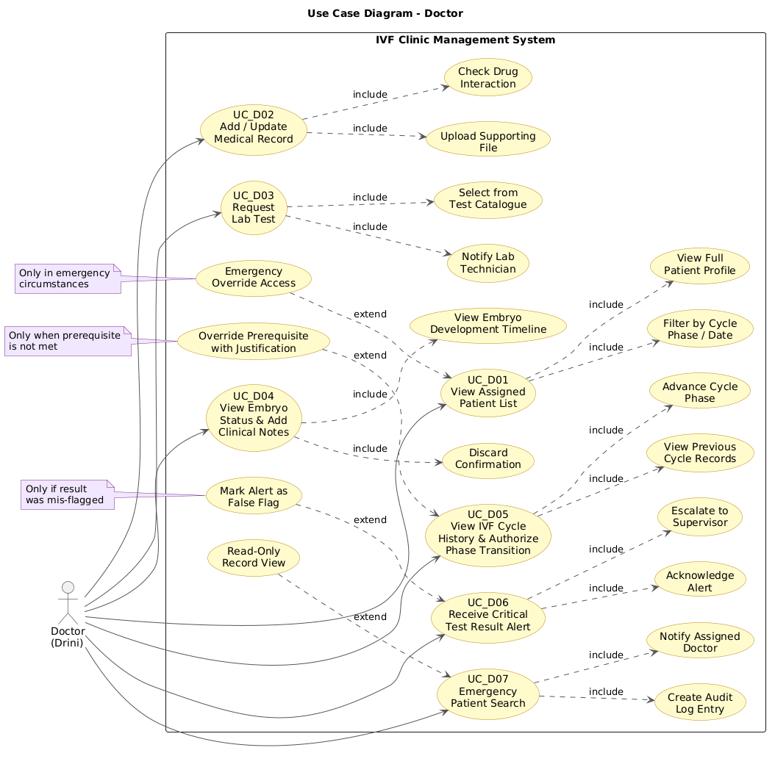

9. Activity Diagrams
This section contains the activity diagrams for each Doctor use case. Insert the corresponding PNG image in the placeholder below each title.

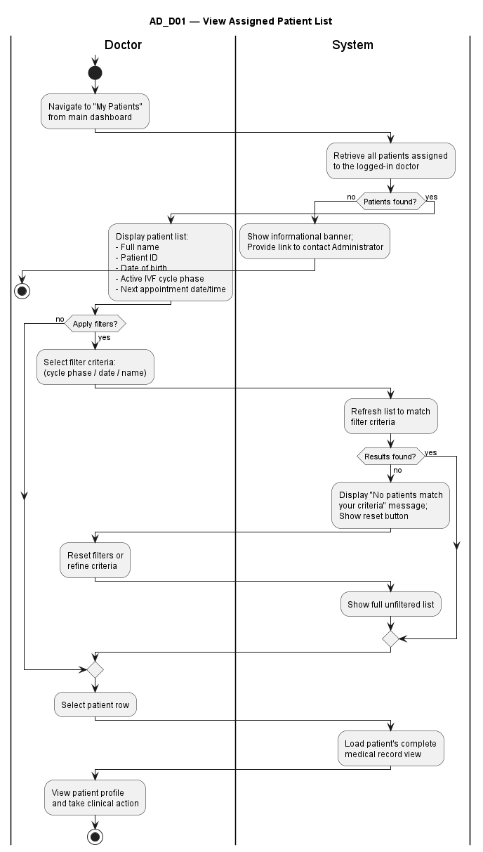
9.1 UC_D01: View Assigned Patient List
Activity diagram for UC_D01: View Assigned Patient List

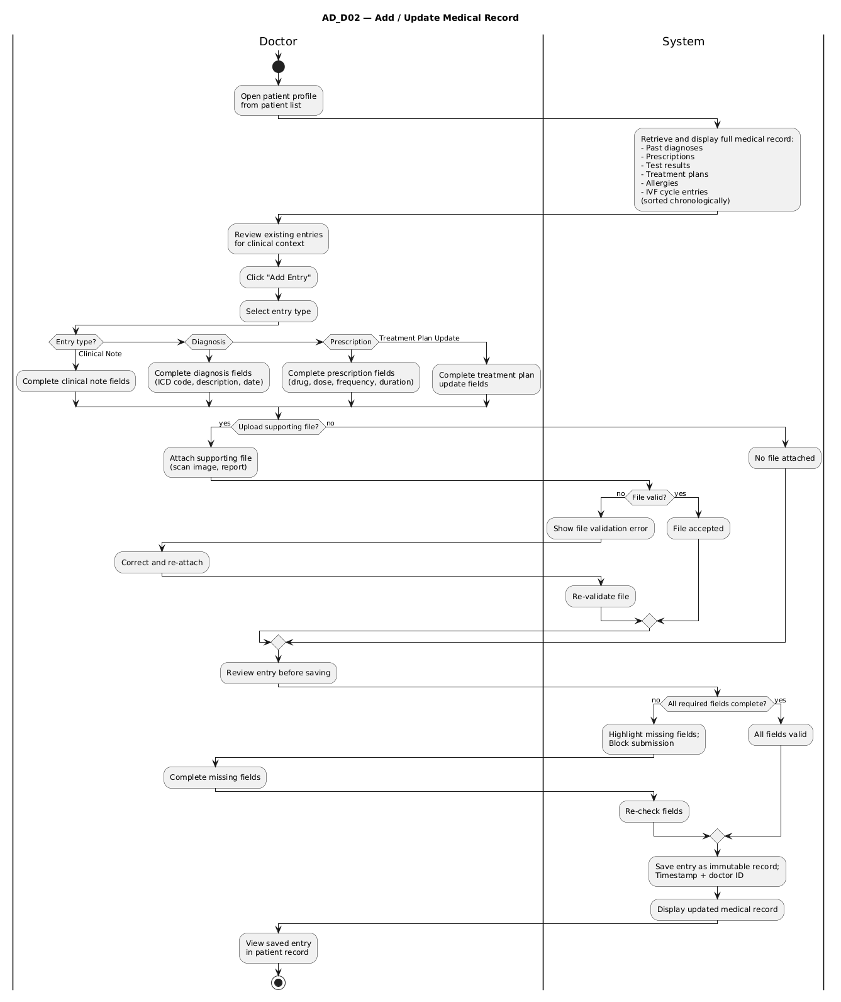
9.2 UC_D02: Add / Update Medical Record
Activity diagram for UC_D02: Add / Update Medical Record

9.3 UC_D03: Create and Manage Appointments
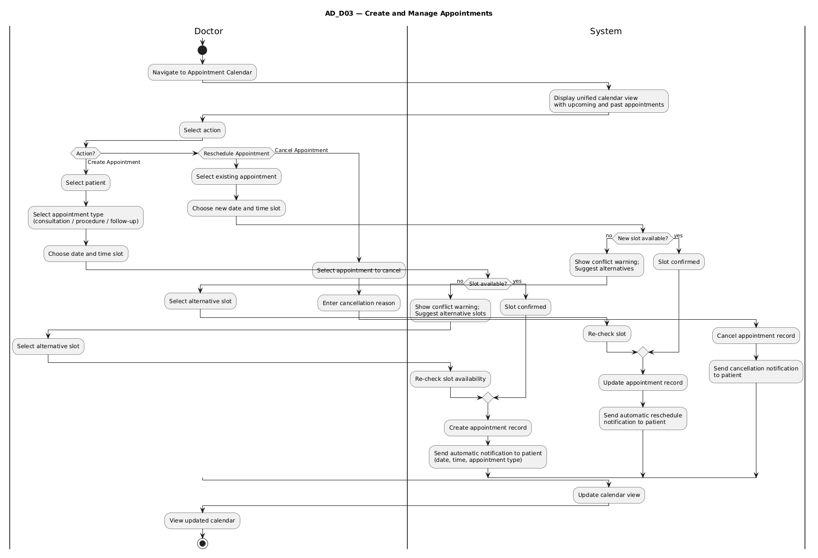

Activity diagram for UC_D03: Create and Manage Appointments

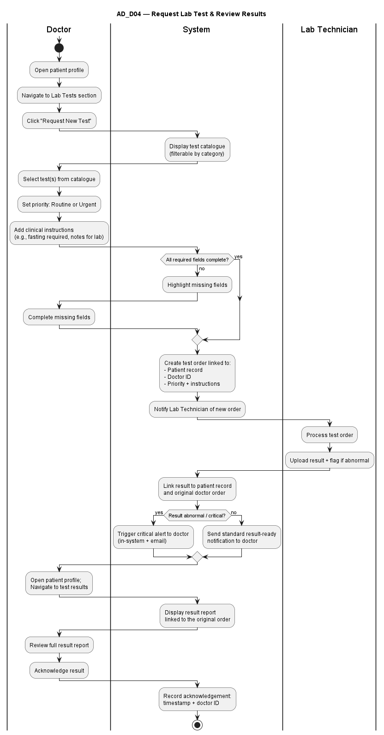
9.4 UC_D04: Request Lab Test and Review Results
Activity diagram for UC_D04: Request Lab Test and Review Results

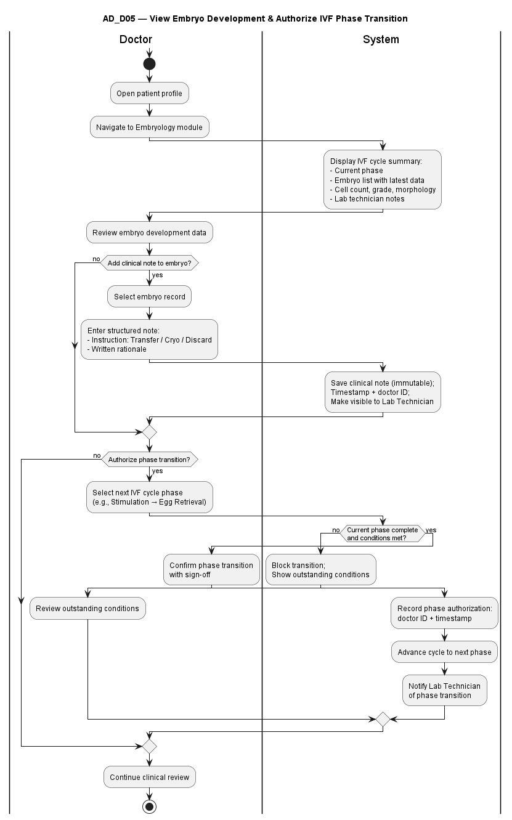
9.5 UC_D05: View Embryo Status and Add Clinical Notes

Activity diagram for UC_D05: View Embryo Status and Add Clinical Notes

9.6 UC_D06: View IVF Cycle History and Authorize Phase Transition
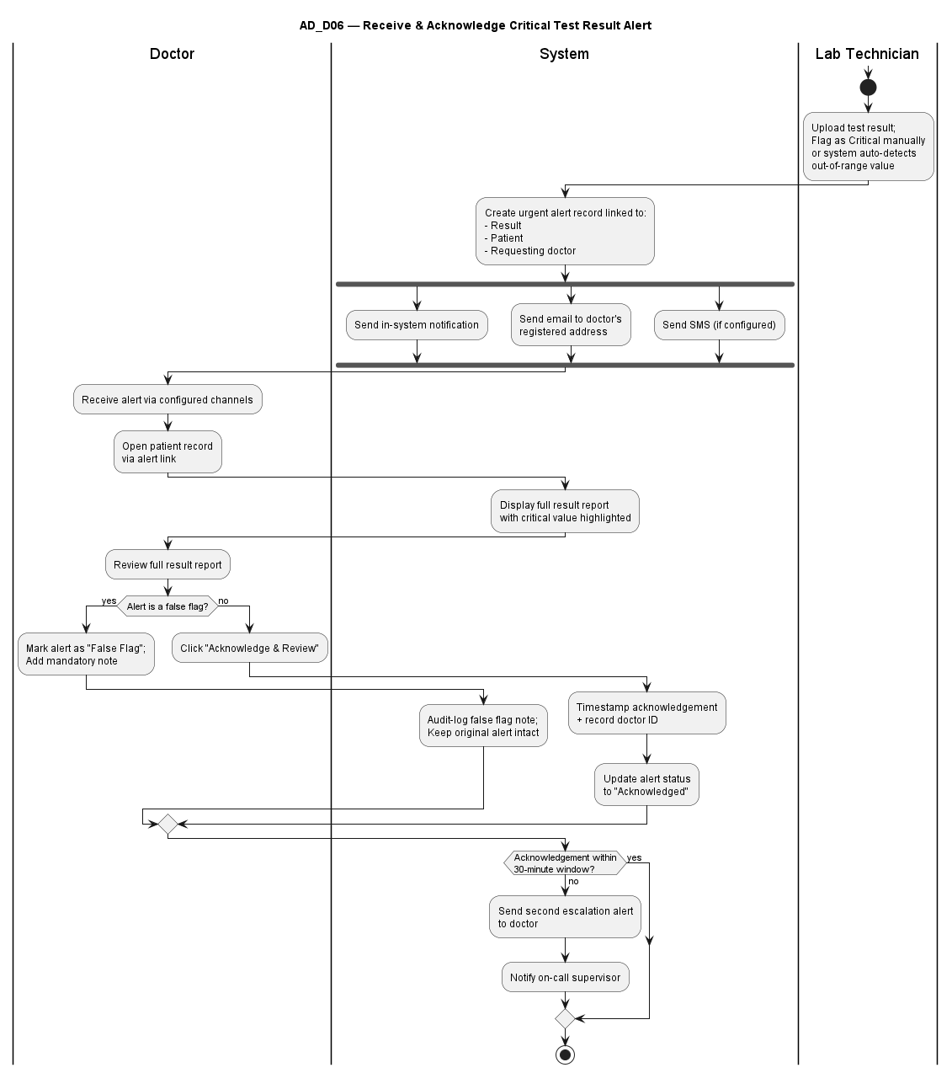
Activity diagram for UC_D06: View IVF Cycle History and Authorize Phase Transition

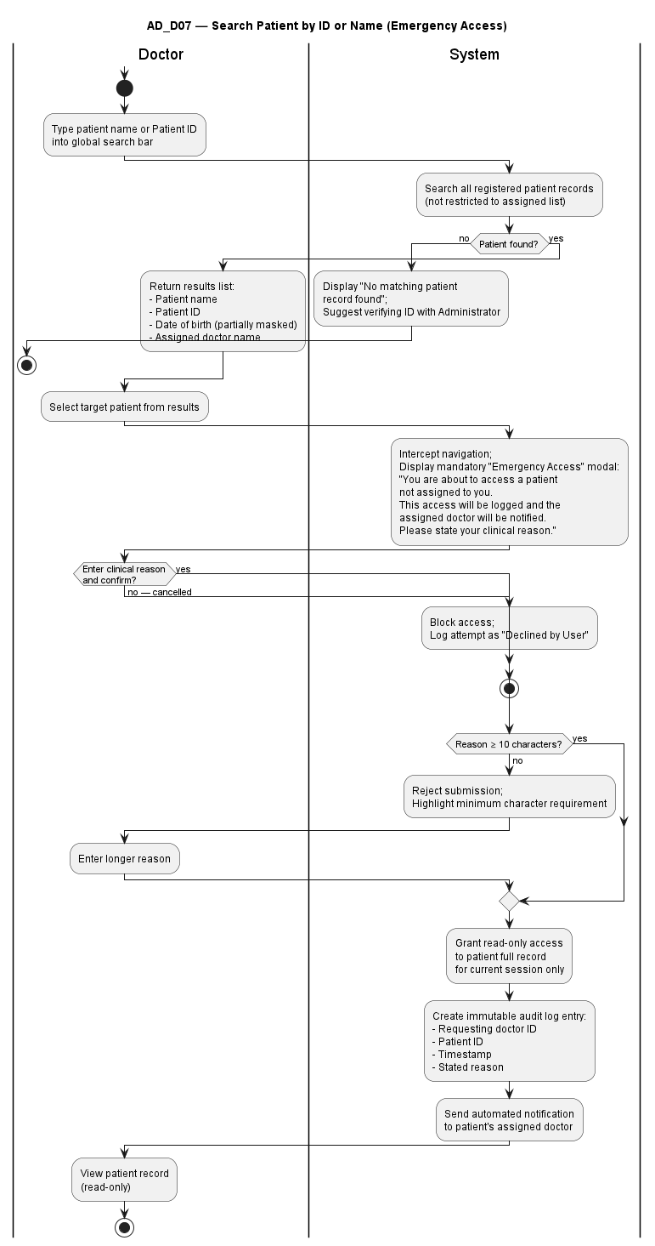
9.7 UC_D07: Emergency Patient Search
Activity diagram for UC_D07: Emergency Patient Search

10. Sequence Diagrams
This section contains the sequence diagrams for each Doctor use case. Insert the corresponding PNG image in the placeholder below each title.

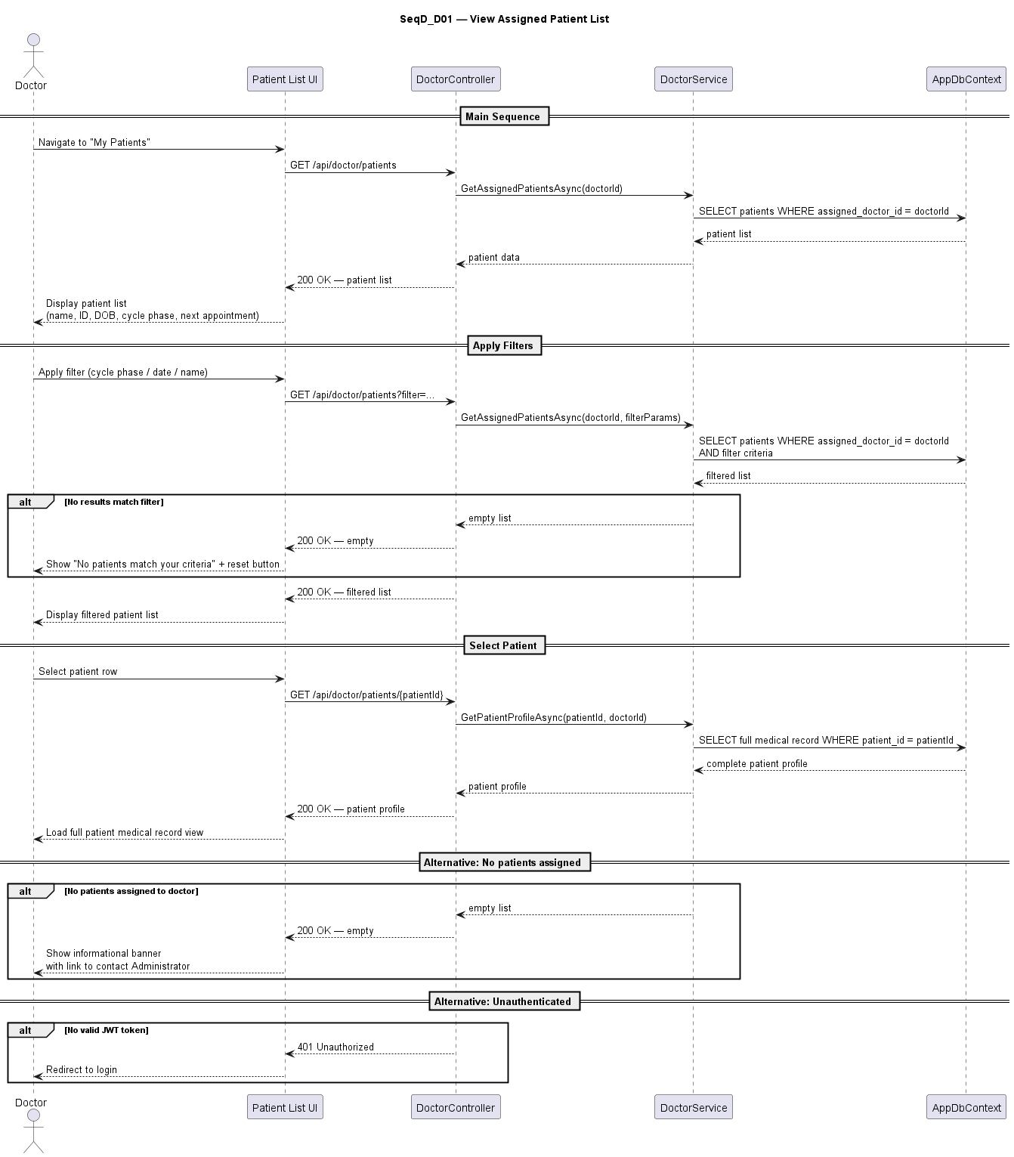
10.1 UC_D01: View Assigned Patient List

Sequence diagram for UC_D01: View Assigned Patient List

10.2 UC_D02: Add / Update Medical Record

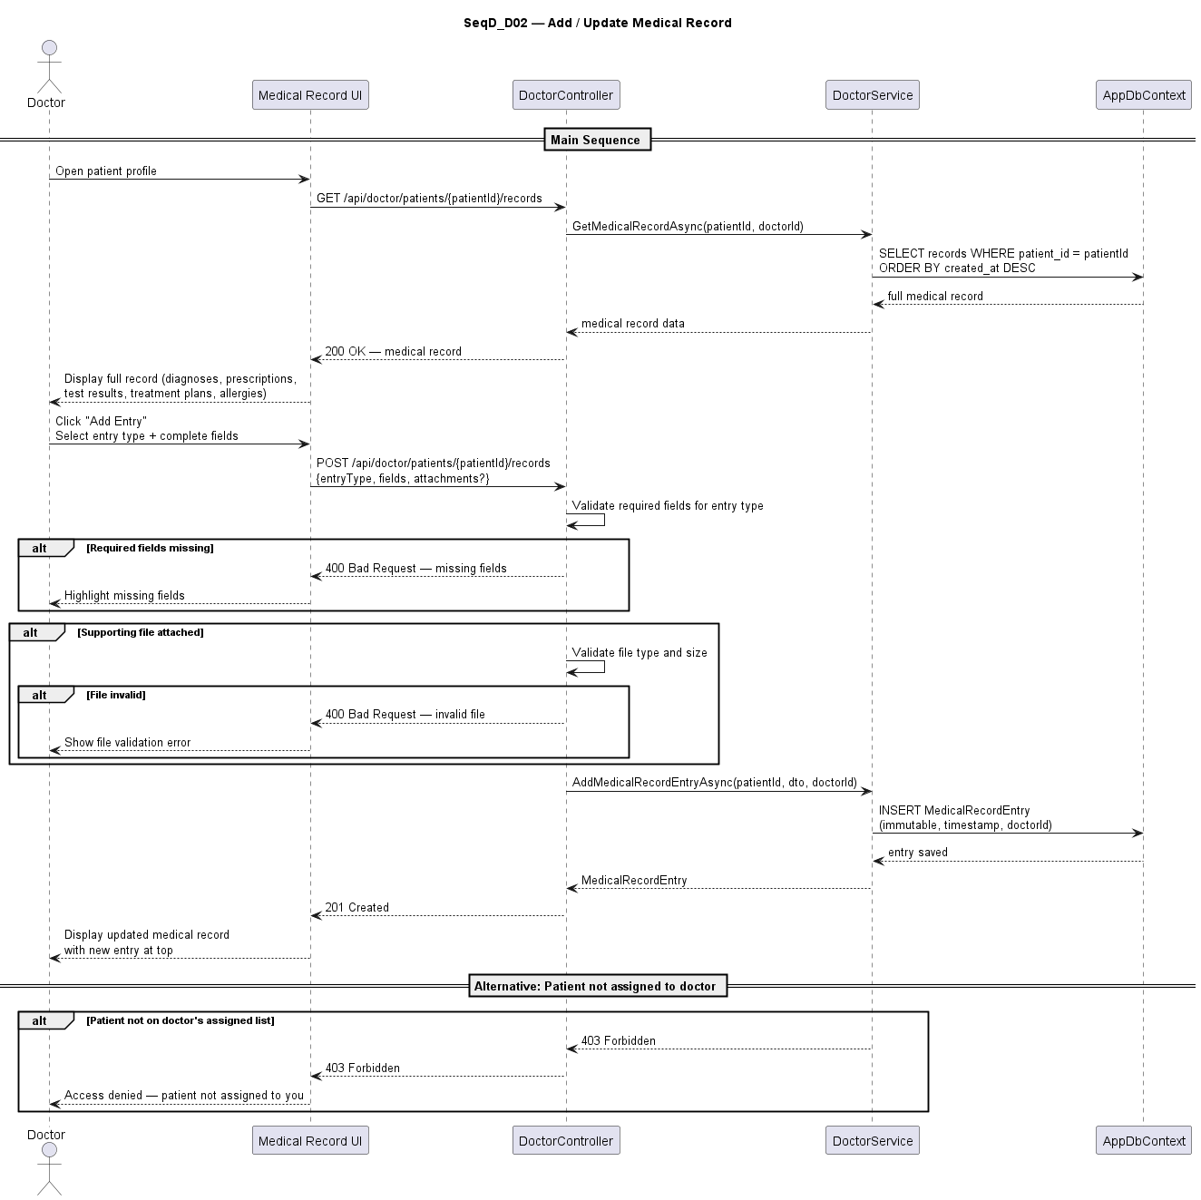

Sequence diagram for UC_D02: Add / Update Medical Record

10.3 UC_D03: Create and Manage Appointments
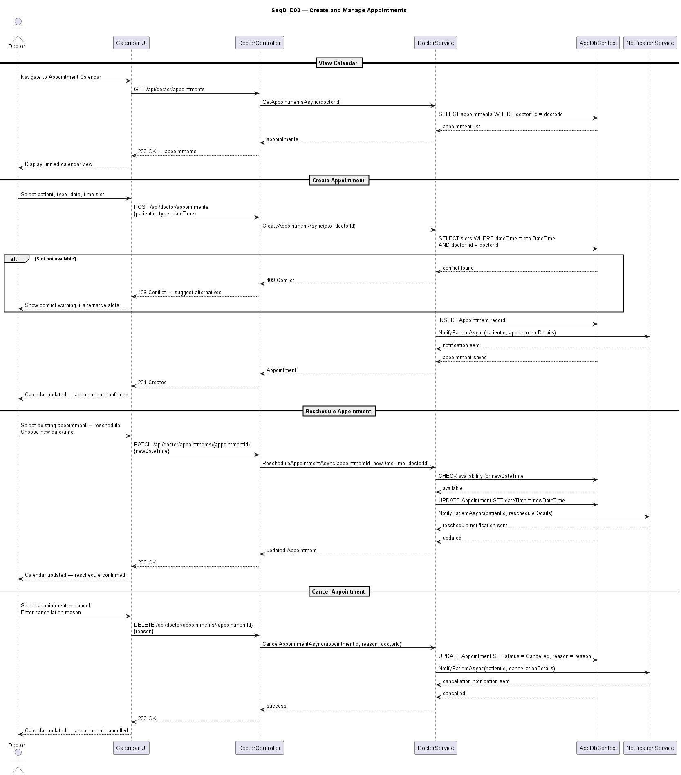
Sequence diagram for UC_D03: Create and Manage Appointments

10.4 UC_D04: Request Lab Test and Review Results
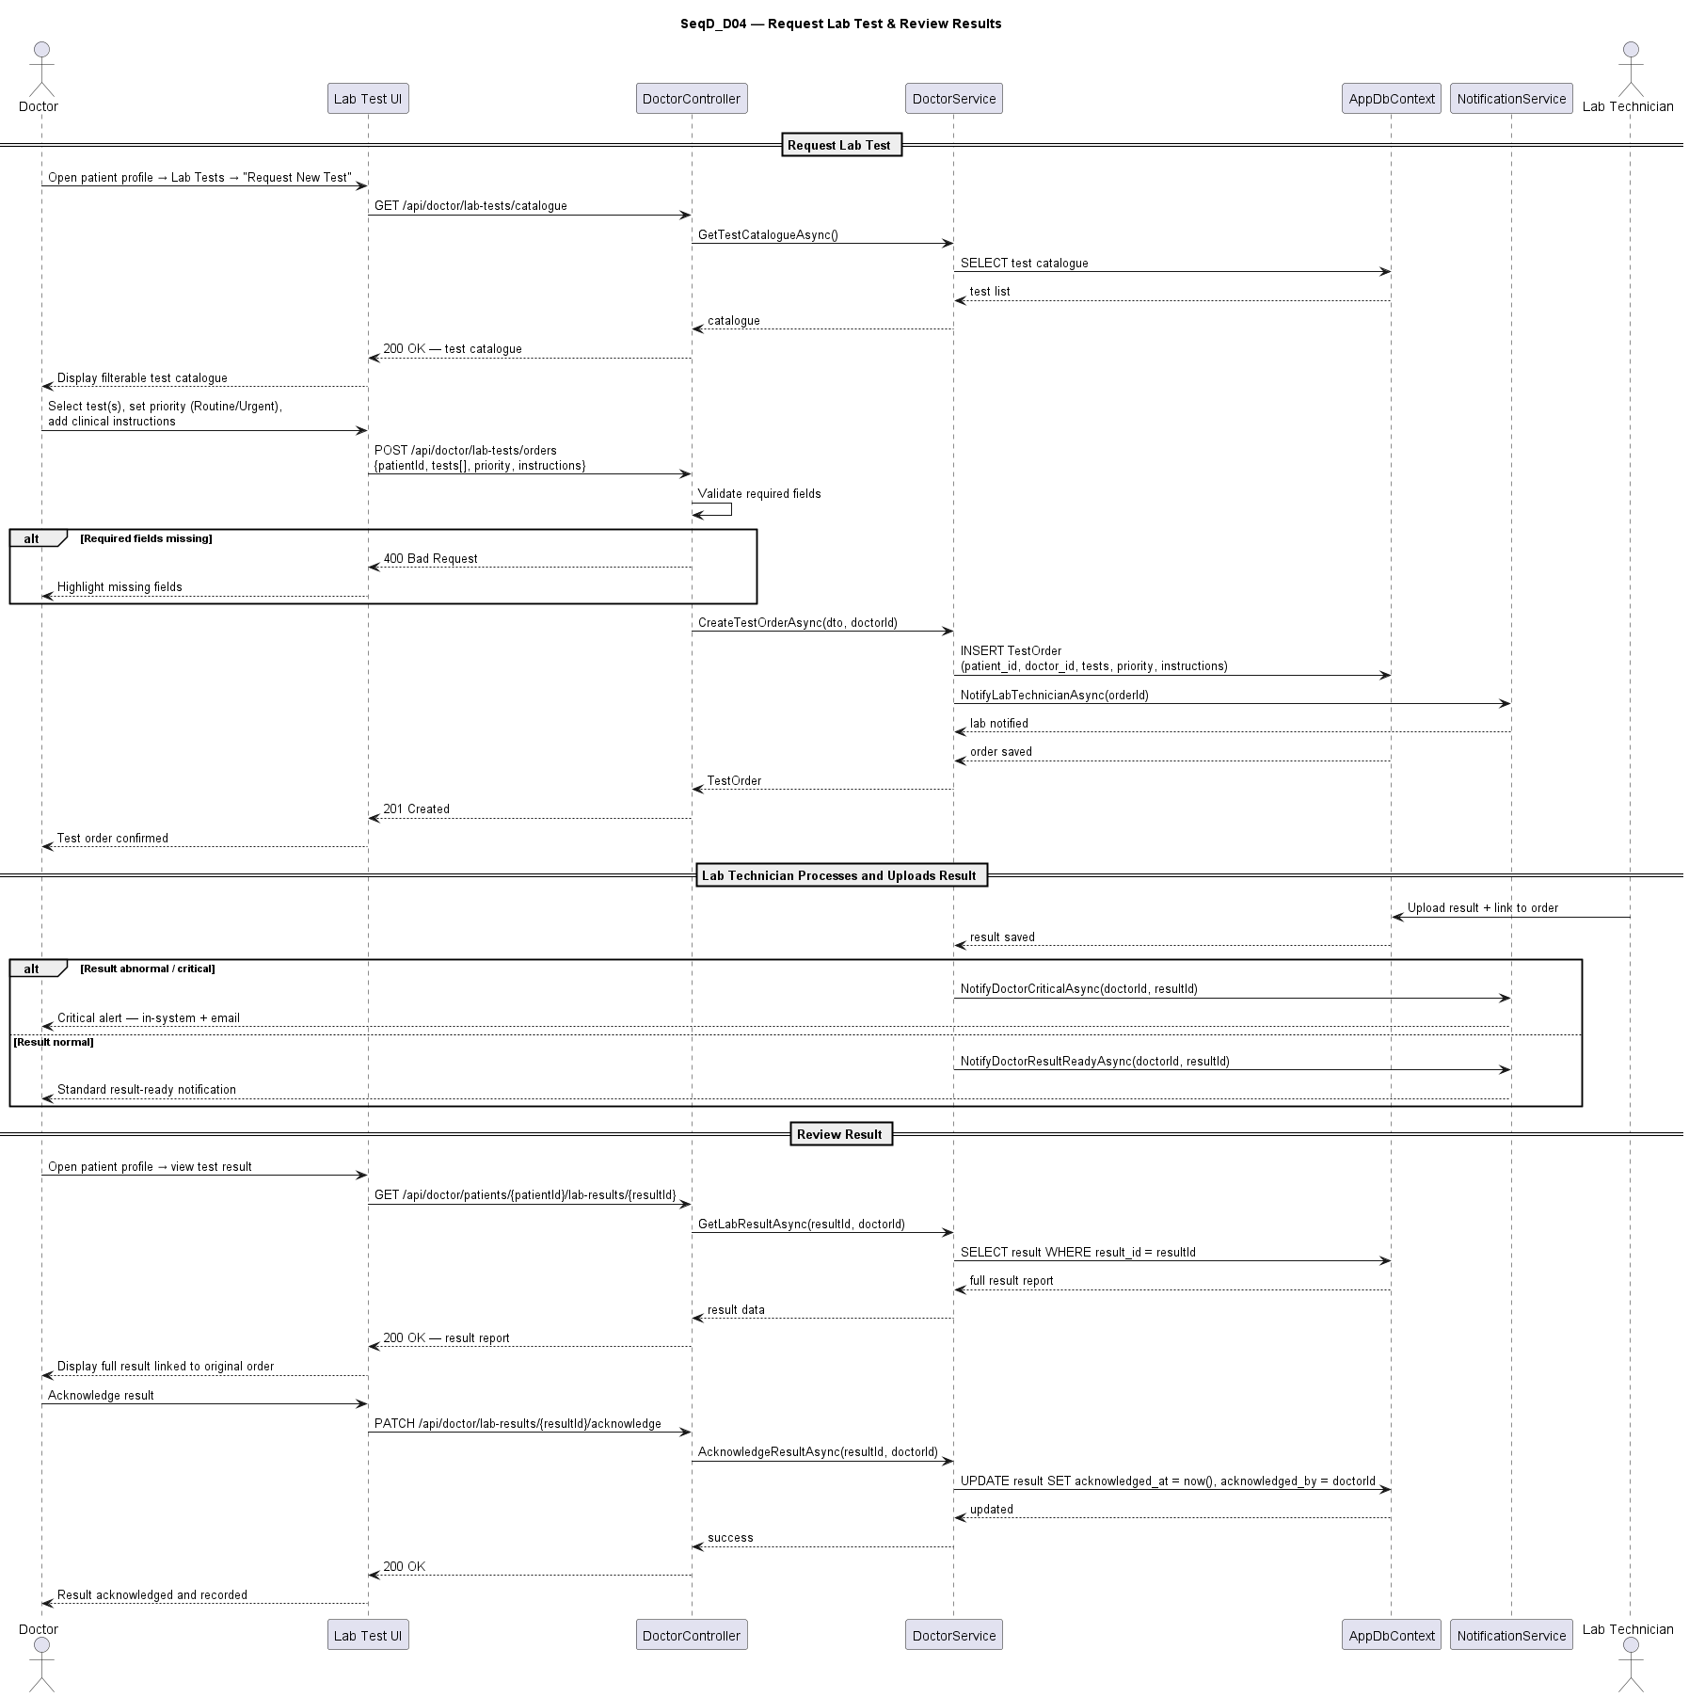
Sequence diagram for UC_D04: Request Lab Test and Review Results

10.5 UC_D05: View Embryo Status and Add Clinical Notes
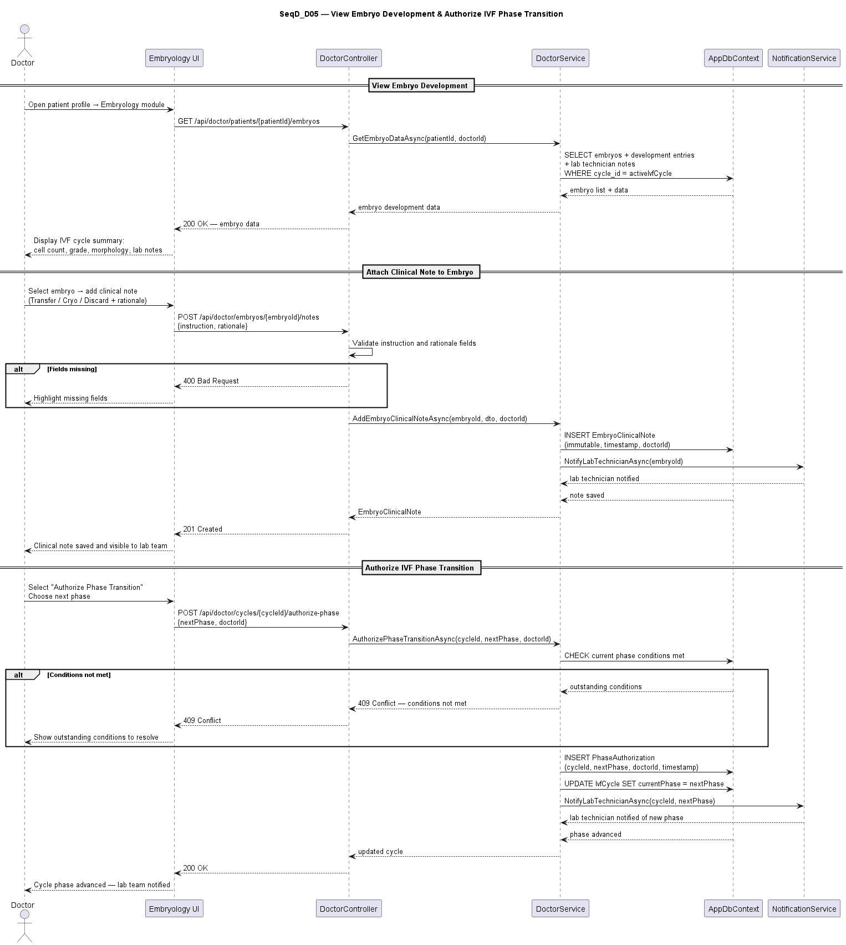
Sequence diagram for UC_D05: View Embryo Status and Add Clinical Notes

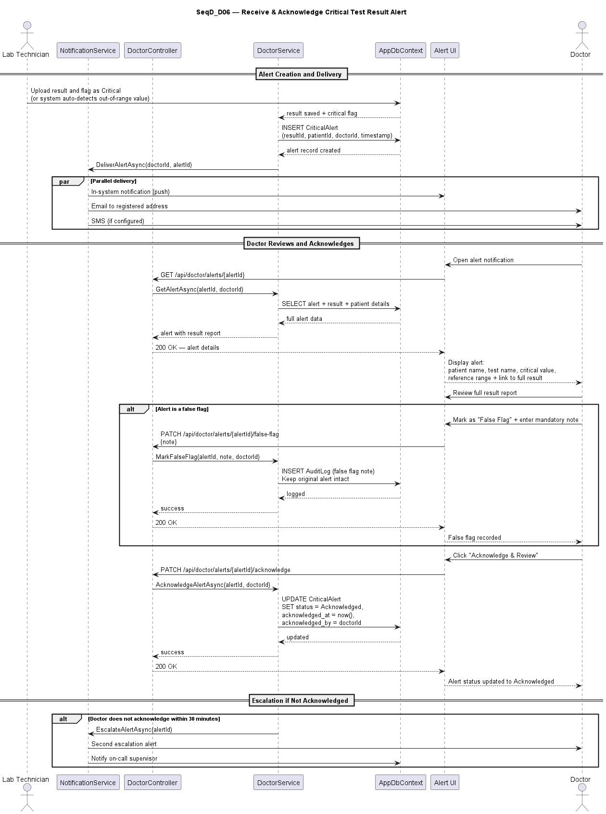
10.6 UC_D06: View IVF Cycle History and Authorize Phase Transition
Sequence diagram for UC_D06: View IVF Cycle History and Authorize Phase Transition

10.7 UC_D07: Emergency Patient Search
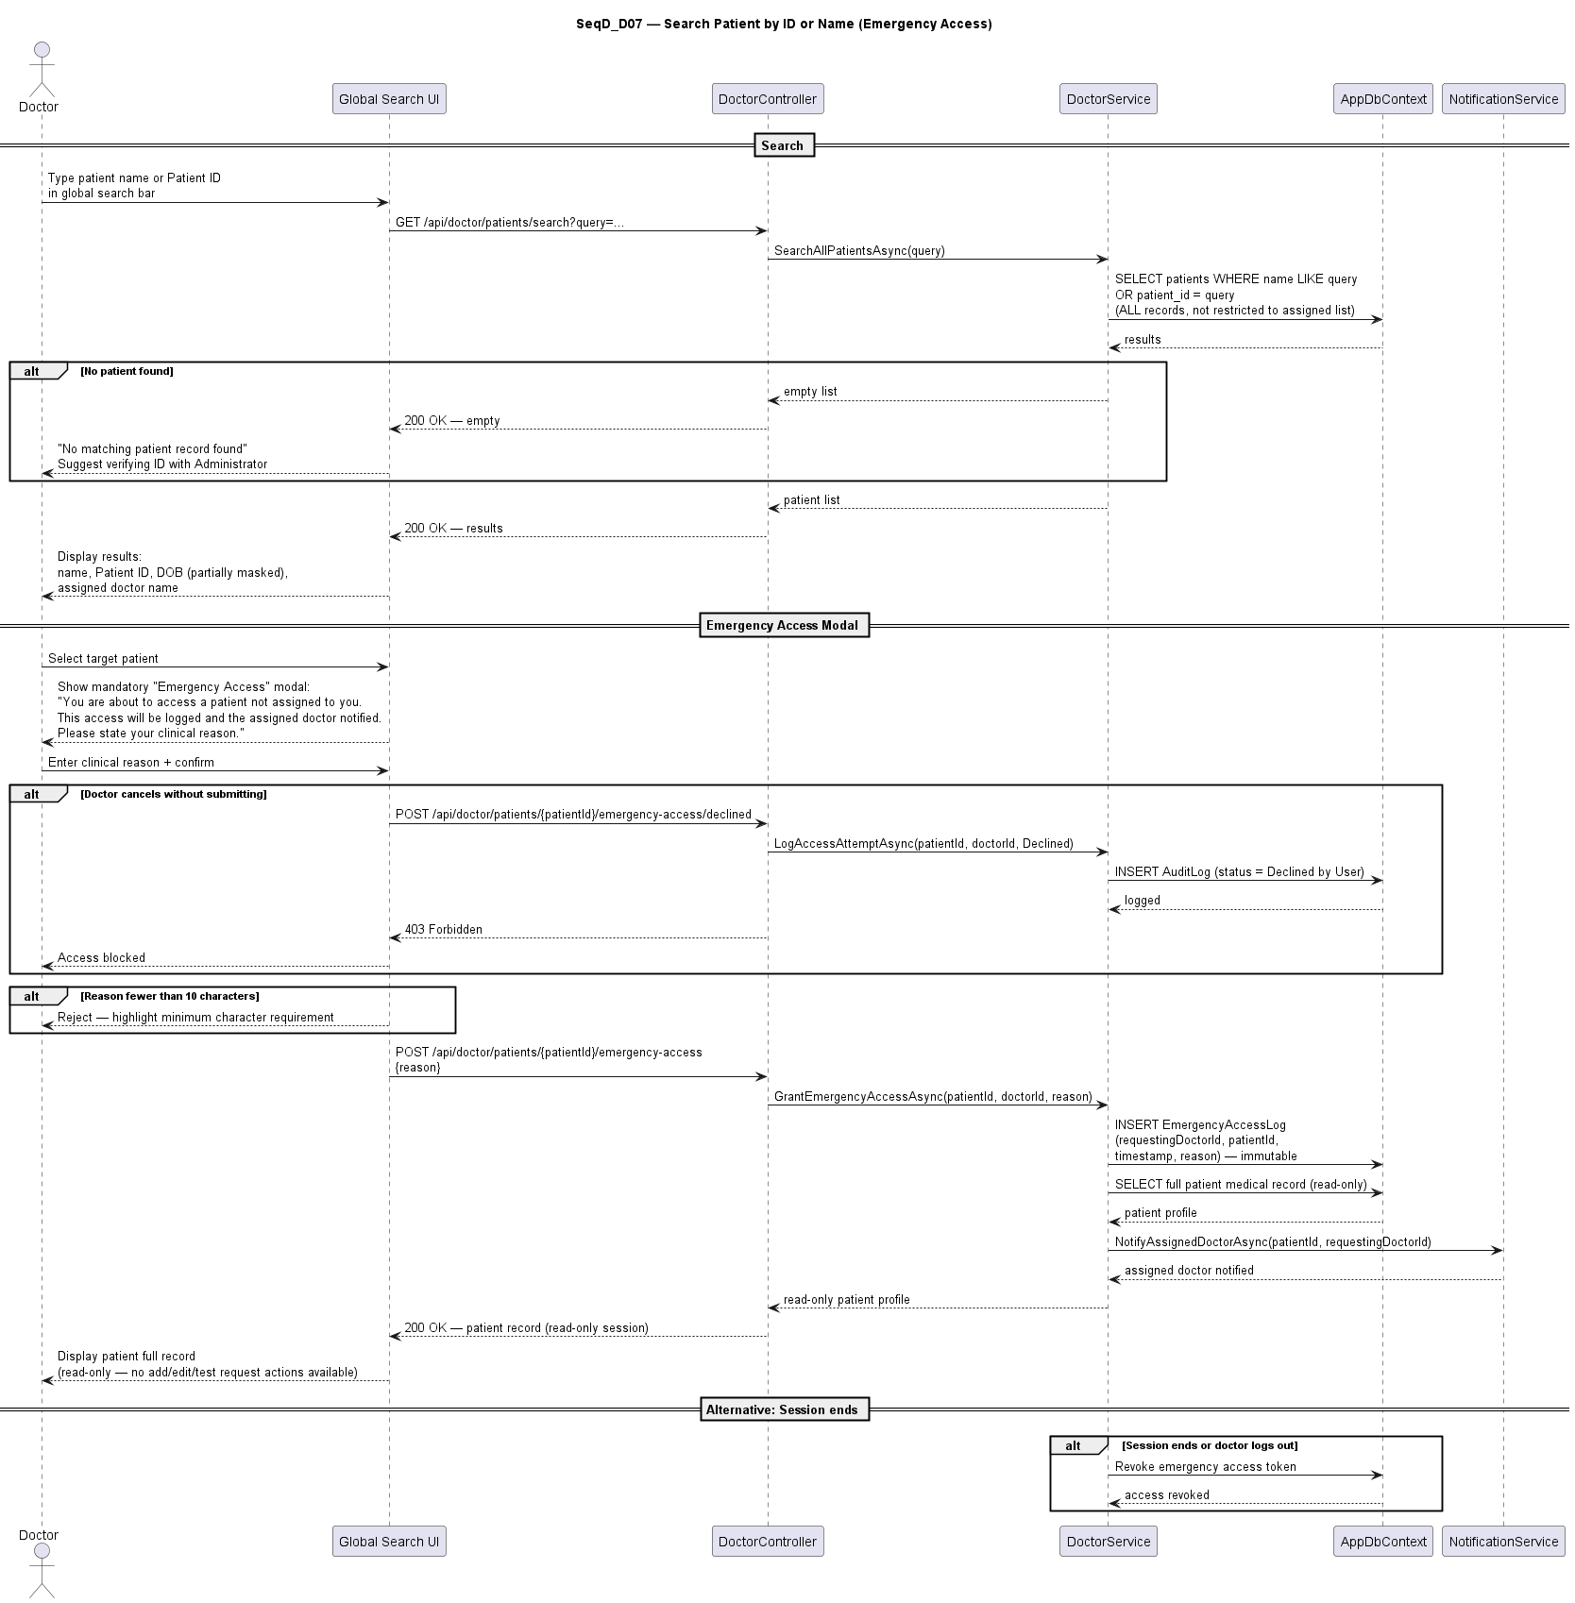
Sequence diagram for UC_D07: Emergency Patient Search

